**BlinkIT_Analysis_Using_Sql_Queries:**

**SELECT * FROM blinkit_db.blinkit_grocery_data;**

-- select count(*) from blinkit_db.blinkit_grocery_data;

* **DATA Cleaning:**

-- UPDATE blinkit_db.blinkit_grocery_data

-- SET Item_Fat_Content =

-- CASE

-- WHEN Item_Fat_Content IN ('LF', 'low fat') THEN 'Low fat'

-- WHEN Item_Fat_Content = 'reg' THEN 'Regular'

-- ELSE Item_Fat_Content

-- END;

//To check how many distinct columns are there in Item_Fat_Content;

–SELECT DISTINCT(Item_Fat_Content) FROM blinkit_db.blinkit_grocery_data;

* **-- KPI requirements:**

1. **Total Sales: the overall revenue generated from all of its items sold:**

select cast(sum(sales)/ 1000000 as DECIMAL(10,2)) as Total_sales_Millions

from blinkit_db.blinkit_grocery_data;

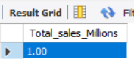

1. **Average Sales: Average sales revenue per sale:**

select cast(AVG(sales) AS DECIMAL(10,0)) as Avg_sales

from blinkit_db.blinkit_grocery_data

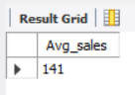

1. **Number of items: the total count of items sold;**

SELECT count(*) as No_of_Items FROM blinkit_db.blinkit_grocery_data;

**OR**

select cast(AVG(sales) AS DECIMAL(10,0)) as Avg_sales

from blinkit_db.blinkit_grocery_data

where Item_Fat_Content= 'Low fat';

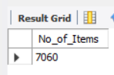

1. **Average Rating : The average customer rating for items sold:**

select cast(avg(Rating) as DECIMAL(10,2)) as Avg_rating from blinkit_db.blinkit_grocery_data;

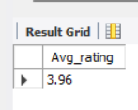

* **GRANULAR REQUIREMENTS:**

1. **Total sales by fats content:**

select Item_Fat_Content,

cast(sum(Sales)/1000 as decimal(10,2) )as Total_sales_Thousands,

cast(AVG(sales) AS DECIMAL(10,0)) as Avg_sales,

count(*) as No_of_Items,

cast(avg(Rating) as DECIMAL(10,2)) as Avg_rating

from blinkit_db.blinkit_grocery_data

where Outlet_Establishment_Year= 2020

group by Item_Fat_Content

order by Total_sales_Thousands

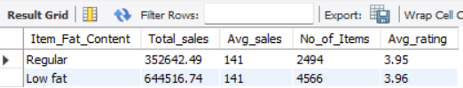

1. **Tota; sales by item Type;**

select Item_Type,

cast(sum(Sales) as decimal(10,2) )as Total_sales,

cast(AVG(sales) AS DECIMAL(10,0)) as Avg_sales,

count(*) as No_of_Items,

cast(avg(Rating) as DECIMAL(10,2)) as Avg_rating

from blinkit_db.blinkit_grocery_data

where Outlet_Establishment_Year= 2020

group by Item_Type

order by Total_sales desc

limit 5

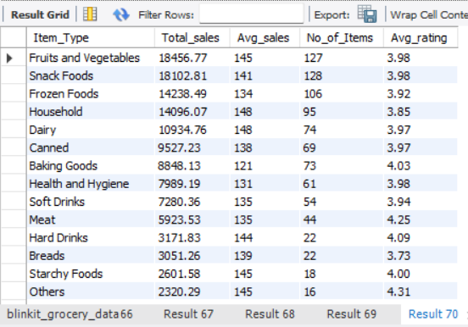

1. **Fat content by outlet for total sales:**

select Outlet_Location_Type, Item_Fat_Content,

cast(sum(Sales) as decimal(10,2) )as Total_sales,

cast(AVG(sales) AS DECIMAL(10,0)) as Avg_sales,

count(*) as No_of_Items,

cast(avg(Rating) as DECIMAL(10,2)) as Avg_rating

from blinkit_db.blinkit_grocery_data

group by Outlet_Location_Type, Item_Fat_Content

order by Total_sales asc;

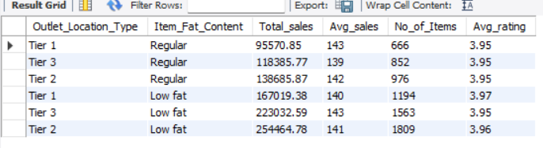

-- SELECT Outlet_Location_Type,

-- ISNULL([Low Fat], 0) AS Low_Fat,

-- ISNULL([Regular], 0) AS Regular

-- FROM

-- (

-- SELECT Outlet_Location_Type, Item_Fat_Content,

-- CAST(SUM(Sales) AS DECIMAL(10,2)) AS Total_Sales

-- FROM blinkit_db.blinkit_grocery_data

-- GROUP BY Outlet_Location_Type, Item_Fat_Content

-- AS SourceTable

-- )

-- PIVOT

-- (

-- SUM(Sales)

-- FOR Item_Fat_Content IN ([Low Fat], [Regular])

-- )AS PivotTable

-- ORDER BY Outlet_Location_Type;

// CORRECTED ONE:

SELECT

Outlet_Location_Type,

CAST(IFNULL(SUM(CASE WHEN Item_Fat_Content = 'Low Fat' THEN Sales ELSE 0 END), 0) AS DECIMAL(10,2)) AS Low_Fat,

CAST(IFNULL(SUM(CASE WHEN Item_Fat_Content = 'Regular' THEN Sales ELSE 0 END), 0) AS DECIMAL(10,2)) AS Regular

FROM blinkit_db.blinkit_grocery_data

GROUP BY Outlet_Location_Type

ORDER BY Outlet_Location_Type;

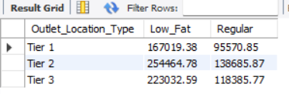

1. **Total sales by outlet establishment;**

select Outlet_Establishment_Year,

cast(sum(Sales) as decimal(10,2) )as Total_sales,

cast(AVG(sales) AS DECIMAL(10,0)) as Avg_sales,

count(*) as No_of_Items,

cast(avg(Rating) as DECIMAL(10,2)) as Avg_rating

from blinkit_db.blinkit_grocery_data

group by Outlet_Establishment_Year

order by Outlet_Establishment_Year asc;

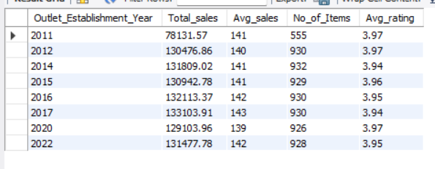

1. **Percentage of sales by outlet size:**

/*

SELECT

Outlet_Size,

CAST(SUM(Sales) AS DECIMAL (10,2)) AS Total_Sales,

CAST((SUM(Sales) * 100.0 / SUM(SUM(Sales)) OVER()) AS DECIMAL (10,2)) AS Sales_Percentage

FROM blinkit_db.blinkit_grocery_data

GROUP BY Outlet_Size

ORDER BY Total_Sales DESC;

*/

SELECT

Outlet_Size,

CAST(SUM(Sales) AS DECIMAL(10,2)) AS Total_Sales,

CAST((SUM(Sales) * 100.0 / (SELECT SUM(Sales) FROM blinkit_db.blinkit_grocery_data)) AS DECIMAL(10,2)) AS Sales_Percentage

FROM blinkit_db.blinkit_grocery_data

GROUP BY Outlet_Size

ORDER BY Total_Sales DESC;

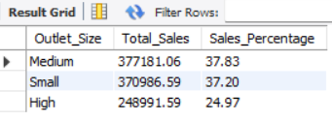

1. **Sales by outlet location:**

select Outlet_Location_Type,

cast(sum(Sales) as decimal(10,2) )as Total_sales,

cast(AVG(sales) AS DECIMAL(10,0)) as Avg_sales,

count(*) as No_of_Items,

cast(avg(Rating) as DECIMAL(10,2)) as Avg_rating

from blinkit_db.blinkit_grocery_data

group by Outlet_Location_Type

order by Total_sales asc;

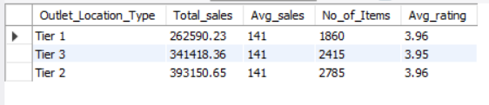

1. **All metrics by outlet type:**

select Outlet_Type,

cast(sum(Sales) as decimal(10,2) )as Total_sales,

cast(AVG(sales) AS DECIMAL(10,0)) as Avg_sales,

CAST((SUM(Sales) * 100.0 / (SELECT SUM(Sales) FROM blinkit_db.blinkit_grocery_data)) AS DECIMAL(10,2)) AS Sales_Percentage,

count(*) as No_of_Items,

cast(avg(Rating) as DECIMAL(10,2)) as Avg_rating

from blinkit_db.blinkit_grocery_data

-- where Outlet_Establishment_Year = 2020

group by Outlet_Type

order by Total_sales asc;

